Mini Dry Bath—Mini50
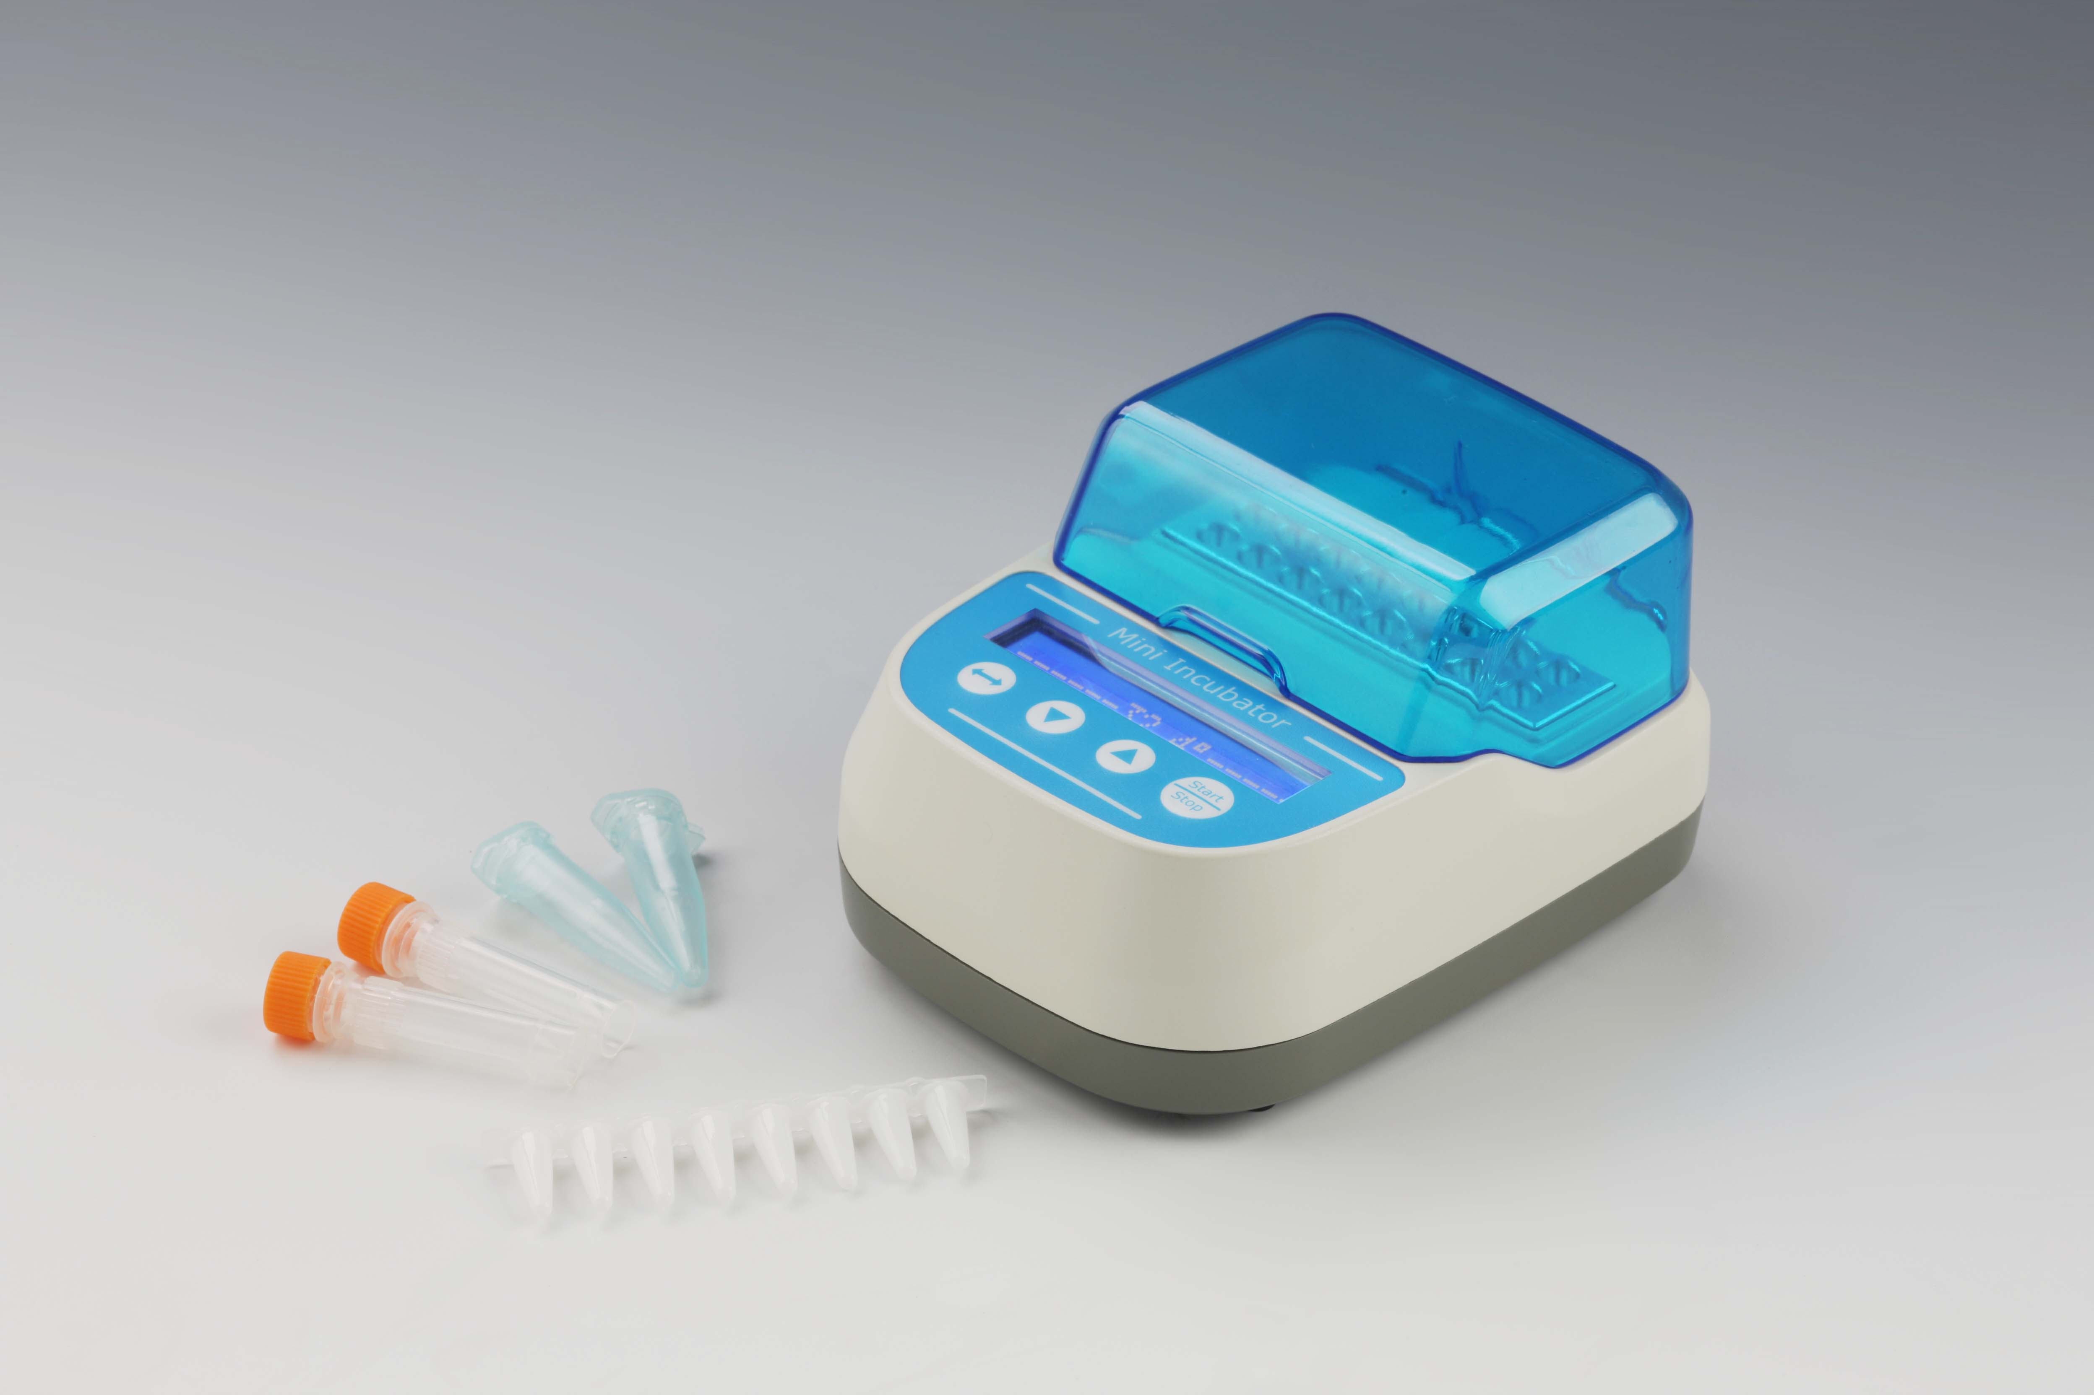
Description:
Mini50 is a microprocessor-controlled product. It is widely used in preservation and reactions of sample, DNA amplification and initial denaturation of electrophoresis and so forth. It fits almost anywhere and can even be used in cars, boats or wherever a 12 volt power source is available.

Features:
- Energy-efficient design.
- Applicable to 12V power adapter.
- High temperature control precision
- Process of experiment is visible.
- Automatic running function.
- Automatic power recovery function.
- Electronic calibration. User can reset to any local standard.
- Custom blocks are accepted to fit different experiment request.
- Built-in software and hardware over-temperature protection device, use more reliable.

Parameters:
Type  Parameters | Mini50
Temp. setting range | 0℃~100℃
Temp. control range | RT.+5℃~100℃
Time range | 1~999h/1~999min/1~999sec/∞
Temp. accuracy | ≤±0.5℃@37℃
Display accuracy | 0.1℃
Temp. uniformity | ≤±0.5℃@37℃
Heating time | ≤15min(from 37℃ to 100℃ )
Auto running | Yes
Auto resume to run | Yes
Power | 24W
Voltage | DC12V/2A
Dimension(mm) | 135×100×75
Weight(kg) | 0.4

Blocks:
Type Description
MD8501 16×0.2ml(PCR tube)
MD8502 6×0.5ml(centrifuge tube)
MD8503 5×1.5ml(centrifuge tube)
MD8504 5×2.0ml(centrifuge tube)
MD8505 6×9.3mm
MD8506 16×0.2ml(enzyme trip)

Note: The block is embedded in the machine and can not be replaced.

